3GPP TSG RAN WG1 Meeting #125 R1-2603875
Dalian, China, May 18-22, 2026

Agenda item: 10.8.3
Source: Cohere Technologies
Title: On Waveform and Frame Structure for 6G ISAC
Document for: Discussion and Decision

1 Introduction
One of the agreements in RAN1#124bis was the following:

___________________________________________________________

Agreement:
Companies are encouraged to provide views on necessity/pros/cons/metrics of LLS and/or SLS and pros/cons/metrics of theoretical waveform characteristics analysis, for evaluation of ISAC waveform and/or integration with communication, to RAN1#125 meeting.
___________________________________________________________

In addition, the FL included the following topics to be prioritized for discussion in RAN1#125:

___________________________________________________________

- Identification of potential enhancements to be applied for CP-OFDM waveform for 6G ISAC, including:
  - Necessity/Expected benefit of enhancement compared to 6GR CP-OFDM for communication
  - Applicable scenarios and sensing modes
- Necessity and potential benefits of specifying a waveform for:
  - TRP-TRP bistatic sensing
  - TRP monostatic
  - UE monostatic
- Identification of potential enhancements to be applied for 6GR frame structure for 6G ISAC, including:
  - Necessity/Expected benefit of enhancement compared to 6GR frame structure for communication
  - Applicable scenarios and sensing modes
- Evaluation method of enhancements to be applied for waveform and/or frame structure for 6G ISAC
  - Necessity/pros/cons/metrics of LLS and/or SLS
  - Pros/cons/metrics of theoretical waveform characteristics analysis
- Identification of new waveforms for 6G ISAC, which is different from 6GR CP-OFDM for communication
  - Necessity/Expected benefit of enhancement compared to 6GR CP-OFDM for communication
  - Applicable scenarios and sensing modes
___________________________________________________________

In this contribution we present an ISAC waveform that meets the requirements in ‎[1] and has the following attributes:
- Requires no overhead when sharing the time-frequency resources with the communication waveform
- Can share the time-frequency resources with any communication waveform (4G, 5G, WiFi, etc.)
- Low complexity
- Flexible Doppler resolution and sensing sensitivity to uncorrelated interference determined by the receiver
- Flexible Doppler spread support for different use cases and frequency bands

To enable simpler integration with 3GPP waveforms, this contribution presents an ISAC system that uses a CP-OFDM as the underlying modulation and demodulation schemes for both sensing and communications as well as pure Zak-OTFS based sensing signal which can deliver improved performance, both without increasing the complexity. Future contributions will cover more scenarios and results for pure Zak-OTFS based ISAC.

The contribution also addresses the FL high priority topics listed above.

2 Proposed ISAC waveform and Tx/Rx structure
Our proposed ISAC system addresses the following issues in current state-of-art ISAC systems, namely, (i) sensing signal overhead and loss in spectral efficiency achieved by communication terminals, (ii) high complexity of mitigating strong self-interference from radar transmitter to radar receiver, and (iii) communication standard specific sensing-signal design which for example, limits the degree of freedom in choosing the desired delay and Doppler resolution.

In this proposal, the sensing signal is overlayed as a weak signal on the existing communication signal and hence does not require any share of resource allocated to the communication signals, resulting in no sensing overhead. The communication receiver is not required to be aware of the sensing signal, which is a weak interference to it. However, it is possible for a communication receiver to cancel the sensing signal and/or to leverage its presence for improved channel estimation.

There are two versions of the proposed ISAC system, one is implemented as a precoder over CP-OFDM which is a pilot of Zak-OTFS-over-CP-OFDM as described in ‎[3] and the other as a pilot of pure Zak-OTFS.

2.1 Sensing signal using Zak-OTFS-over-CP-OFDM
The block diagram of the transmitter of the proposed ISAC system is shown in Figure 1. The sensing signal is a quasi-periodic localized pulse centered at delay and Doppler (DD) coordinates $(τ_{0},ν_{0})$ in the DD domain with delay period $τ_{p}$ and a Doppler period $ν_{p}=1/τ_{p}$ that is given by

$$p_{dd,τ_{0},ν_{0}}\left(τ, ν\right)=\sum_{m∈z}{\sum_{n∈z}{\left[e^{j2πν_{0}nτ_{p}}δ\left(τ-nτ_{p}-τ_{0}\right)δ\left(ν-mν_{p}-ν_{0}\right)\right]}}$$

where ${0≤τ}_{0}≤τ_{p}$ and $0≤ν_{0}≤ν_{p}$ (see ‎[2]). The value for $τ_{p}$ is set by the selection of M (number of grid points in the delay dimension) which in the current proposal is set to the number of subcarriers in the band resulting in $τ_{p}=1/SCS$. In the Doppler direction, no filter is applied to the Dirac pulse resulting in $N=∞$. An Inverse Discrete Zak Transform (IDZT) transforms the delay-Doppler into time samples and then groups of M points are transformed to the frequency domain using DFT and are assigned to a sensing Time-Frequency grid which is identical to the communication grid (see ‎[3]). The sensing Time-Frequency grid is then overlaid over the communication grid, and the result is converted to time domain samples in a standard CP-OFDM modulator and transmitted. The time domain representation of this sensing signal is shown in Figure 2.

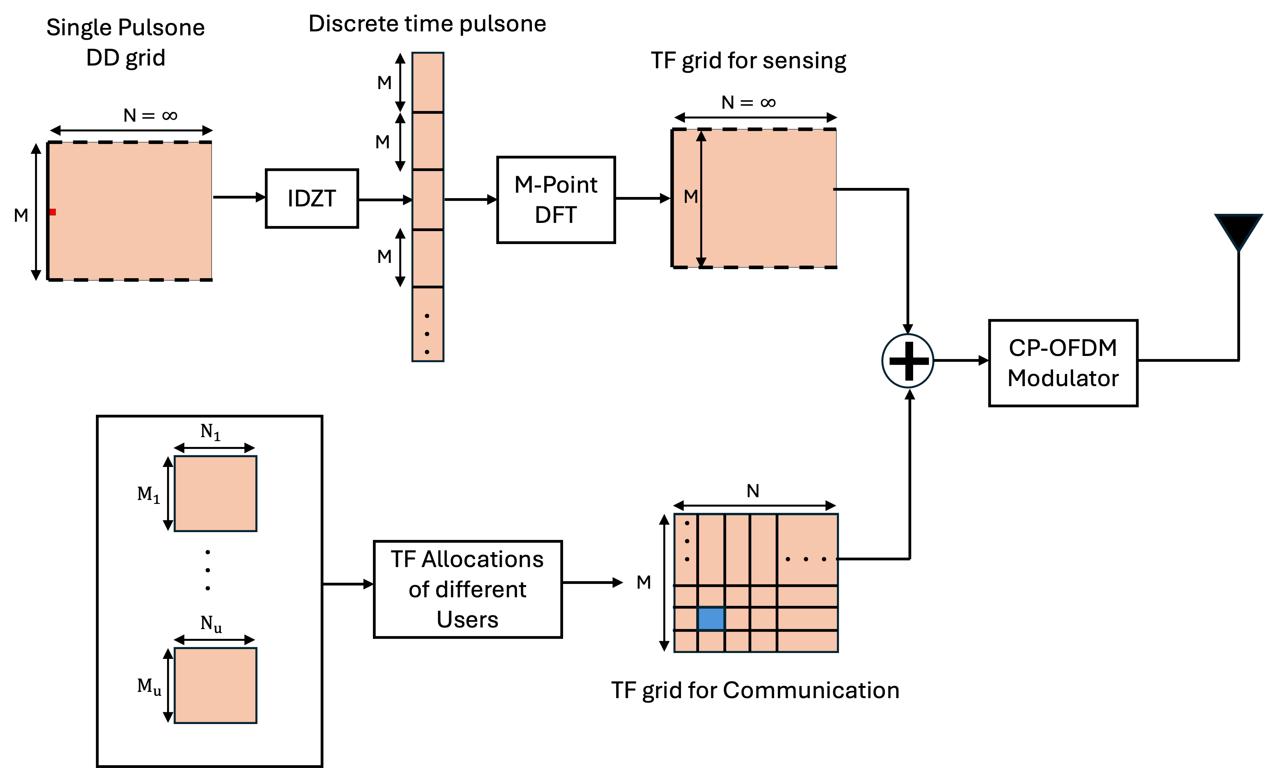
Figure 1: Block Diagram of a Transmitter for Zak-OTFS-over-OFDM based ISAC

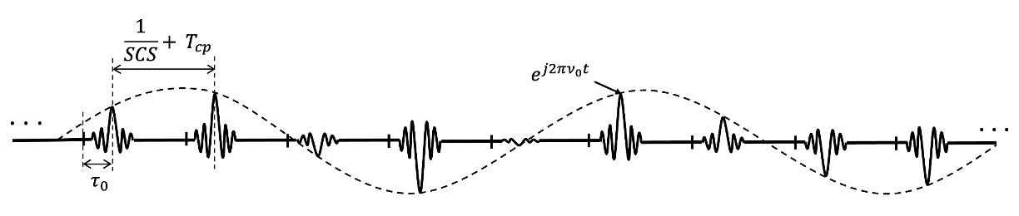
Figure 2: Time domain of sensing signal using Zak-OTFS-over-CP-OFDM

Observation 1: The sensing signal based on overlaying of Zak-OTFS-over-OFDM pilot over the communications signal is agnostic to the communication signal and can share the time-frequency resources with any communication waveform (4G, 5G, WiFi, etc.)

As the proposed sensing signal is overlayed on top of the CP-OFDM, we can make the following observations:

Observation 2: The sensing signal based on overlaying of Zak-OTFS-over-OFDM is considered as enhancement to 6GR CP-OFDM for communication

Observation 3: The sensing signal based on overlaying of Zak-OTFS-over-OFDM is applicable to all sensing modes

The block diagram of a monostatic sensing receiver for the transmitted signal in Figure 1 is shown in Figure 3. The receiver first blocks the incoming signal during the time of the Tx pilot to remove the interfering sensing signal. The signal then goes through the CP-OFDM demodulator and the self-interference and background reflections removal. Following the interference removal, a finite Time-Frequency grid is generated by collecting M subcarriers from N OFDM symbols. Then, M-point Inverse Discrete Fourier Transform (IDFT) is applied to each symbol. The results are concatenated to an M∙N vector and transformed to delay-Doppler using the Discrete Zak Transform (DZT). The result is a discrete delay-Doppler domain, where detection algorithms are applied. Note that the number of OFDM symbols N is selected by the receiver and can be different based on the desired Doppler resolution and sensing SINR (larger N improves the resolution and SINR).
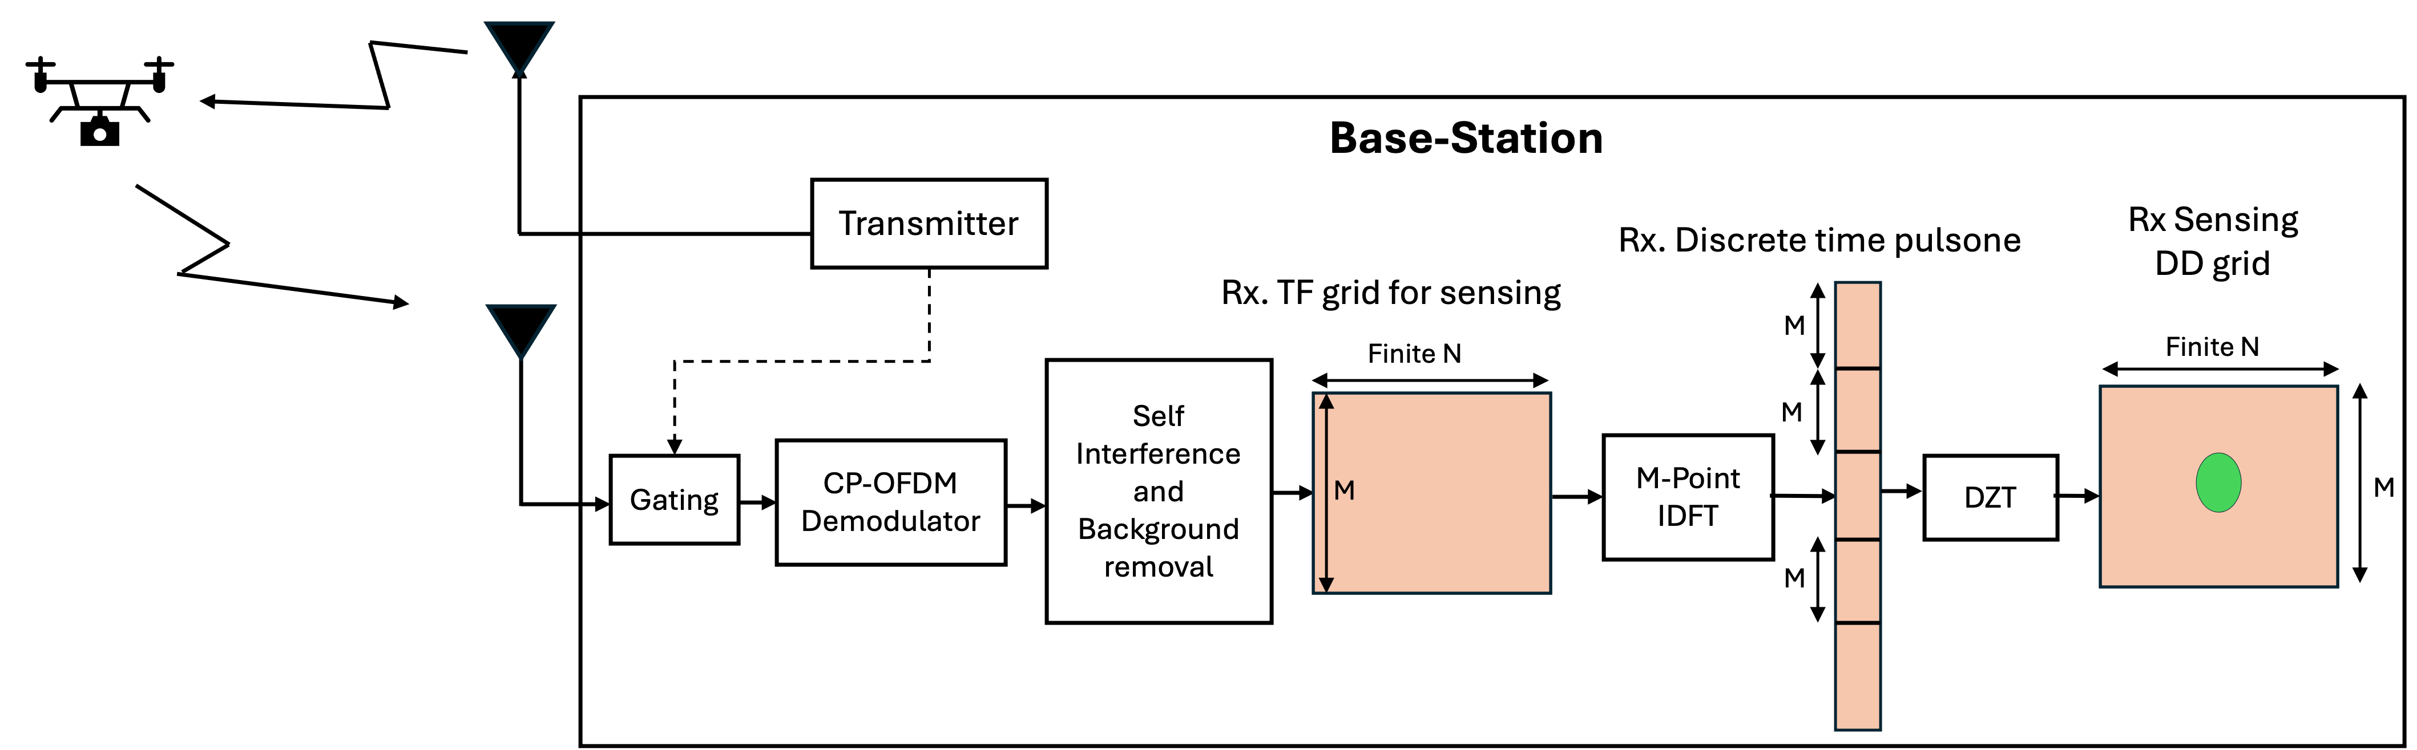
Figure 3: Block Diagram of a Receiver for Zak-OTFS-over-OFDM based ISAC
Observation 4: Using the Zak-OTFS-over-OFDM pilot as the sensing signal enables the use of a simple gating function to remove the sensing self-interference, simplifying the sensing receiver implementation.

Observation 5: The complexity associated with using the Zak-OTFS-over-OFDM based pilot is lower than using OFDM-based reference signals:
- The complexity of transferring the reflected signal to the delay-Doppler domain is NMlog(M)
- The self-interference removal using a gating function is lower complexity than self-interference removal using OFDM-based reference signals

Observation 6: The proposed Zak-OTFS-over-OFDM based ISAC, by sending the sensing pilot with no Doppler filter enables immediate sensing with no gaps in time and provides full flexibility to the sensing receiver to pick the CPI and by that the Doppler resolution and the sensing SINR appropriate for each sensing scenario.

2.1 Sensing signal using pure Zak-OTFS
The sensing signal is a quasi-periodic localized pulse centered at delay and Doppler (DD) coordinates $(τ_{0},ν_{0})$ in the DD domain with delay period $τ_{p}$ and a Doppler period $ν_{p}=1/τ_{p}$ that is given by

$$p_{dd,τ_{0},ν_{0}}\left(τ, ν\right)=\sum_{m∈z}{\sum_{n∈z}{\left[e^{j2πν_{0}nτ_{p}}δ\left(τ-nτ_{p}-τ_{0}\right)δ\left(ν-mν_{p}-ν_{0}\right)\right]}}$$

where ${0≤τ}_{0}≤τ_{p}$ and $0≤ν_{0}≤ν_{p}$ (see ‎[2]). The values for $τ_{p}$ is set by the selection of M (number of grid points in the delay dimension) and is selected to be larger than the roundtrip delay from the TRP to the farthest target. In the Doppler direction, no filter is applied to the Dirac pulse resulting in $N=∞$, and in the delay domain a custom filter is applied to control the ambiguity function, reducing its sidelobes and improving target resolution, and to meet the spectral mask requirements of the transmitted signal. An Inverse Discrete Zak Transform (IDZT) transforms the delay-Doppler into time samples. The sensing signal is then overlaid over the communication signal, and the result is transmitted.

An equivalent implementation of the transmitter and receiver shown in Figure 4. In this implementation the quasi-periodic impulse train is implemented in the time domain and then convolved with the delay filter before being overlayed over the communication signal. The time domain representation of this sensing signal is shown in Figure 5.

In the receiver, after gating the sensing pulse, the signal goes through a filter matched to the delay filter, then through a time window the size of the CPI (selected by the receiver) and then transformed to the delay-Doppler domain by a Zak transform.

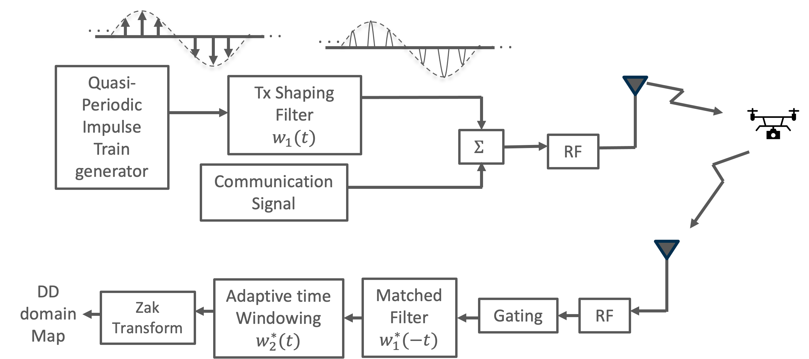
Figure 4: Block diagram of pure Zak-OTFS based ISAC system

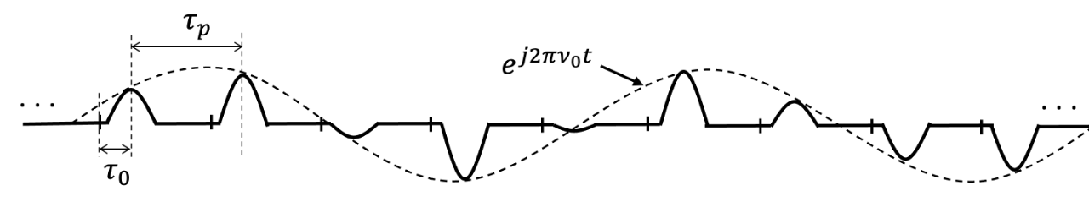
Figure 5: Time domain of sensing signal using pure Zak-OTFS
Based on the description of the pure Zak-OTFS based ISAC system we can observe the following:

Observation 7: The sensing signal based on overlaying of pure Zak-OTFS pilot over the communications signal is agnostic to the communication signal and can share the time-frequency resources with any communication waveform (4G, 5G, WiFi, etc.)

Observation 8: The sensing signal based on overlaying of pure Zak-OTFS is applicable to all sensing modes

Observation 9: Using the pure Zak-OTFS pilot as the sensing signal enables the use of a simple gating function to remove the sensing self-interference, simplifying the sensing receiver implementation.

Observation 10: The complexity associated with using the Zak-OTFS-over-OFDM based pilot is lower than using OFDM-based reference signals:
- The complexity of transferring the reflected signal to the delay-Doppler domain is Mlog(M)Nlog(N)
- The self-interference removal using a gating function is lower complexity than self-interference removal using OFDM-based reference signals

Observation 11: The proposed pure Zak-OTFS based ISAC, by sending the sensing pilot with no Doppler filter provides full flexibility to the sensing receiver to pick the CPI and by that the Doppler resolution and the sensing SINR appropriate for each sensing scenario.

3 Performance evaluation

3.1 Evaluation assumptions
The simulation parameters used for this contribution are for the case of Zak-OTFS-over-CP-OFDM, cover monostatic sensing in 4/1 TDD as shown in Figure 6, and are summarized in Table 1.

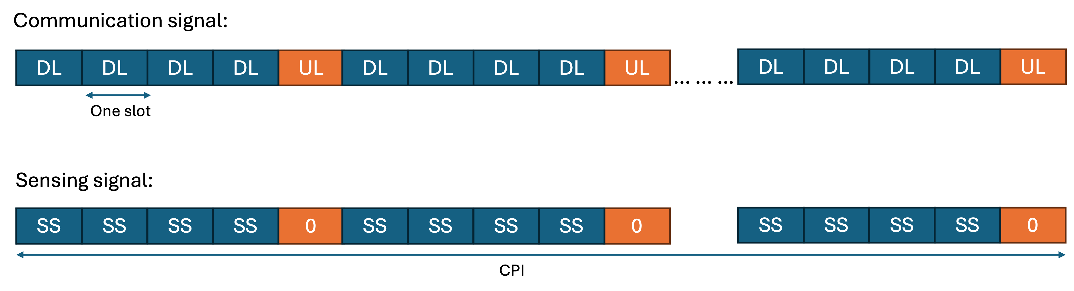
Figure 6: TDD frame structure for ISAC simulations

Table 1: ISAC simulations system configuration
Parameters | Values
Scenario | (UMa-AV, 500m)
Carrier Frequency | 4.9 GHz
Channel BW | 100 MHz
Subcarrier Spacing | 30 kHz
BS height | 25 m
Max Tx Power | 52 dBm
BS antenna configuration | Tx: (8,8) wide beam  Rx: (8,8)  (d_H,d_V ) = (0.5, 0.5)λ, single polarization
Target Type | Small UAV
Number of Targets per sector in center site | 5
Horizontal plane of target | Uniformly distributed in sector
Vertical plane of target | Uniformly distributed between 25m and 300m
Minimum distance between targets | 10m
Minimum distance BS to targets | 10m
Self Isolation | 80 dB

Three TRPs as shown in Figure 7 were used to sense the sector of interest. The pilots sent by each of the TRPs were spread equally along the delay plane resulting in orthogonal pilots.

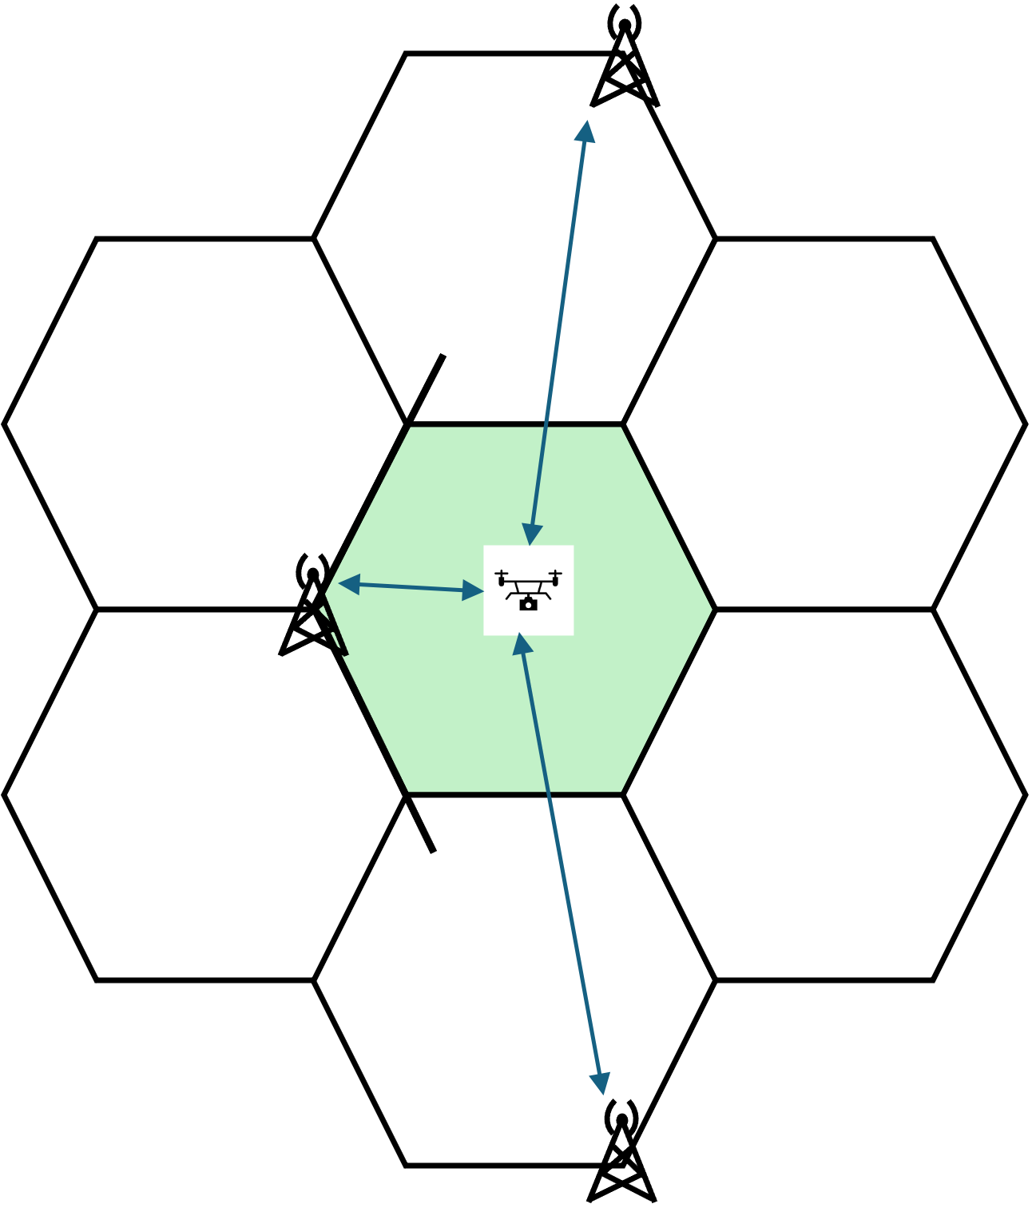
Figure 7: Three TRPs sensing configuration

3.2 Post processing
A flowchart of the receiver processing modules of the Zak-OTFS-over-CP-OFDM based sensing used for the target detection and association is shown in Figure 8. The processing starts with channel estimation per OFDM symbol followed by self-interference and background removal. M-point IDFT and DZT are used to transfer the signal to the DD domain where beamforming is used for mapping the received signal at the direction of each beam. A 2D CFAR is then applied to each beam to detect the range-Doppler peaks followed by a range-Doppler beam clustering. For each detected range-Doppler bin, the MUSIC algorithm is applied across the antenna array to estimate the direction of arrival of the targets. Using the estimated directions, the position and radial velocity of the targets are then computed. With measurements from multiple TRPs, a target is declared as detected if at least two TRPs (one from the serving sector and another from an adjacent sector) identify the target at approximately the same location based on a minimum 3D distance criterion. Finally, the detected targets are associated with the true targets based on minimum 3D distance and velocity thresholds. After association, performance metrics such as horizontal and vertical position accuracy, velocity accuracy, and error probabilities (including miss detection and false alarm rates) are evaluated.

The communication receiver is assumed to not be aware of the sensing signal and as such it is considered as noise/interference.

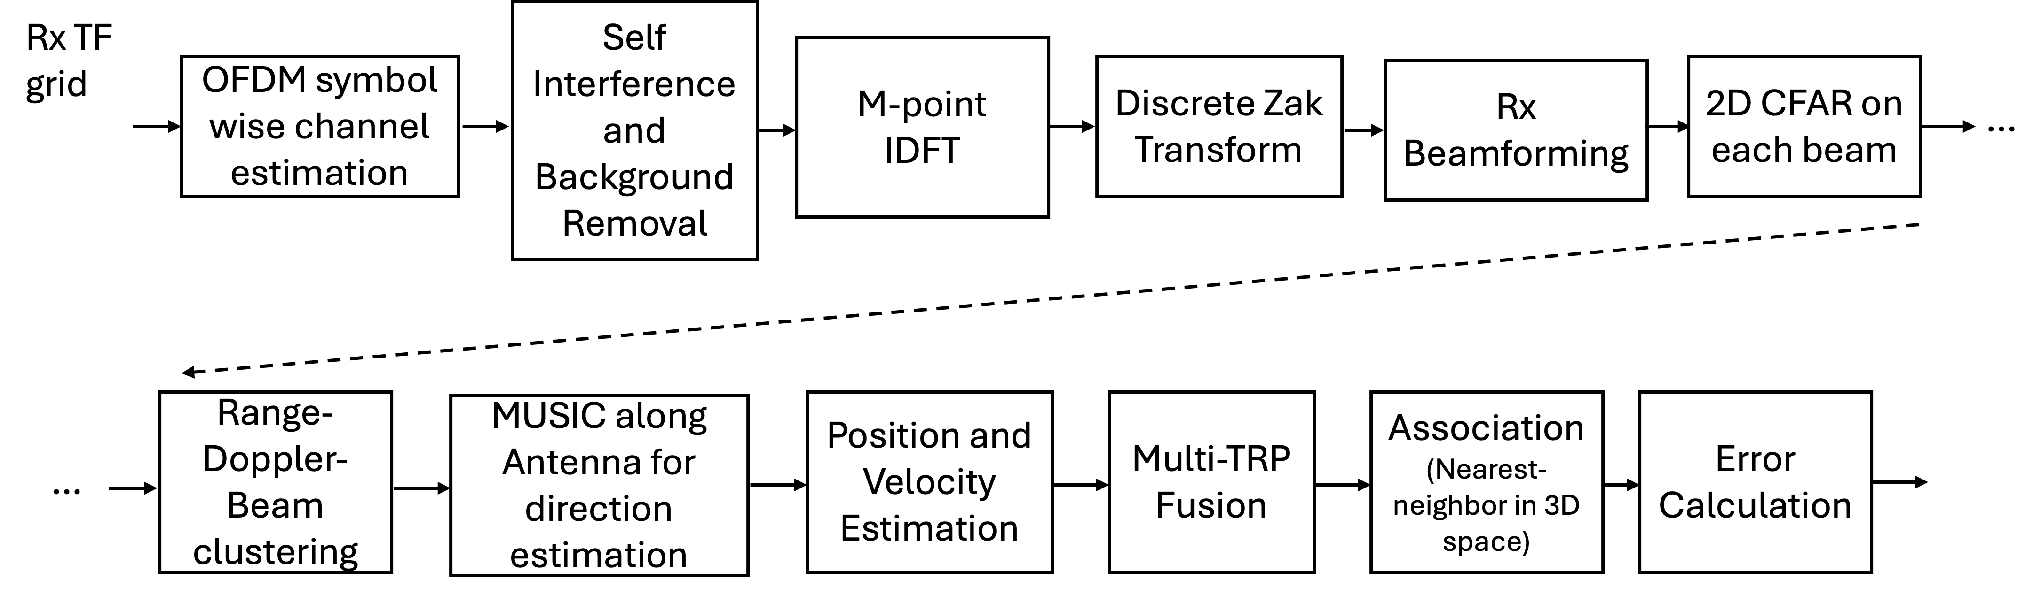
Figure 8: Flowchart for Multi Target Detection and Association using Zak-OTFS-over-OFDM sensing

3.3 Evaluation scenarios
Our current results are provided for the case of Zak-OTFS-over-CP-OFDM based sensing for scenarios covering different Sensing to Data Power Ratio (SDPR) levels and CPIs (receiver side) as shown in Table 2.

Table 2: ISAC simulation scenarios
Scenario | SPDR | CPI | Self-interference
Scenario 1 | -25 dB | 40 ms | Simulated
Scenario 2 | -25 dB | 80 ms | Simulated
Scenario 3 | -32 dB | 160 ms | Simulated

3.4 Performance results

3.4.1 Sensing performance - Scenario 1
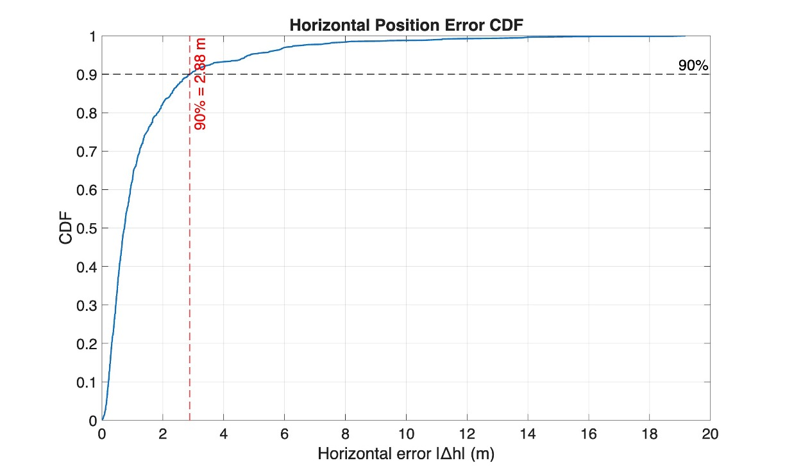 | 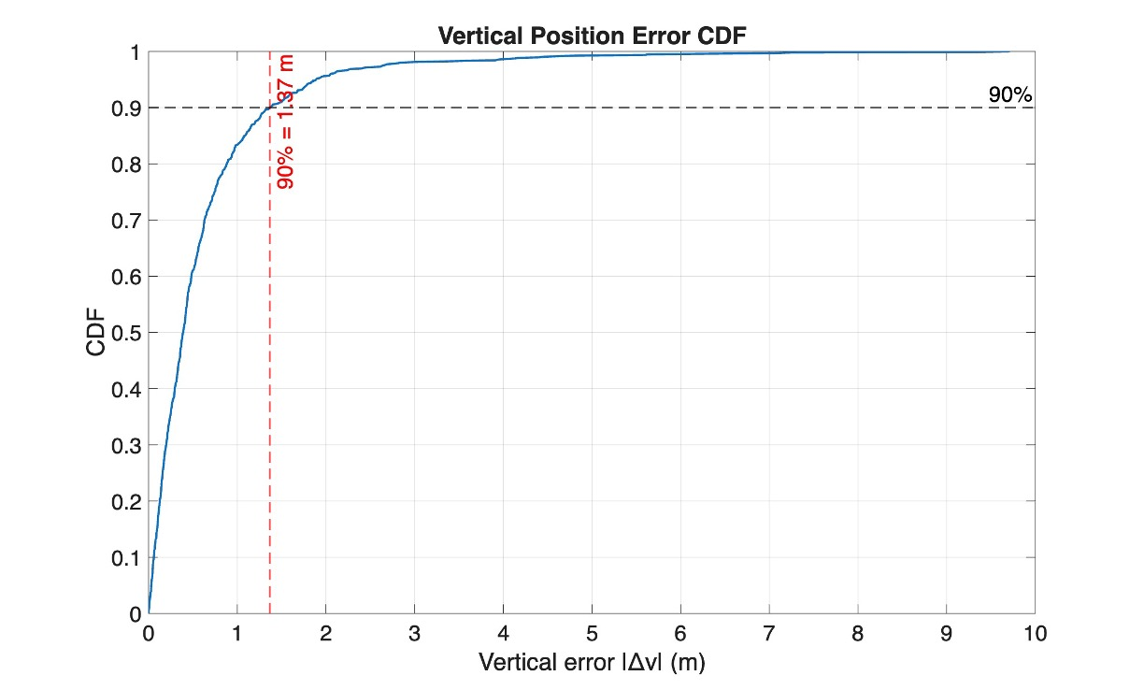 | 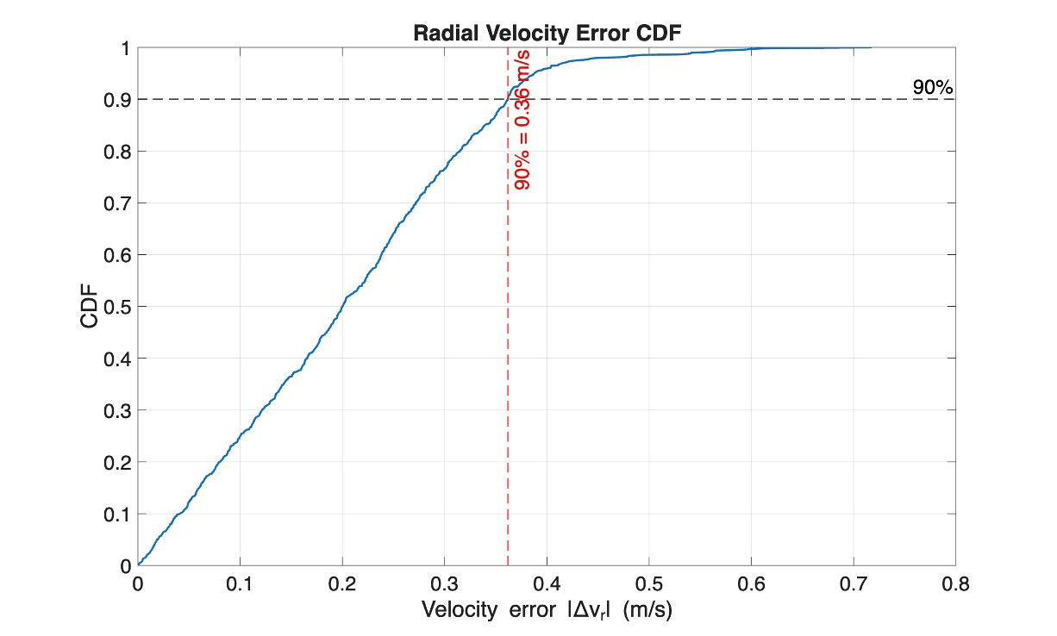
Figure 9: Horizontal, vertical, and velocity performance - Scenario 1

3.4.2 Sensing performance - Scenario 2
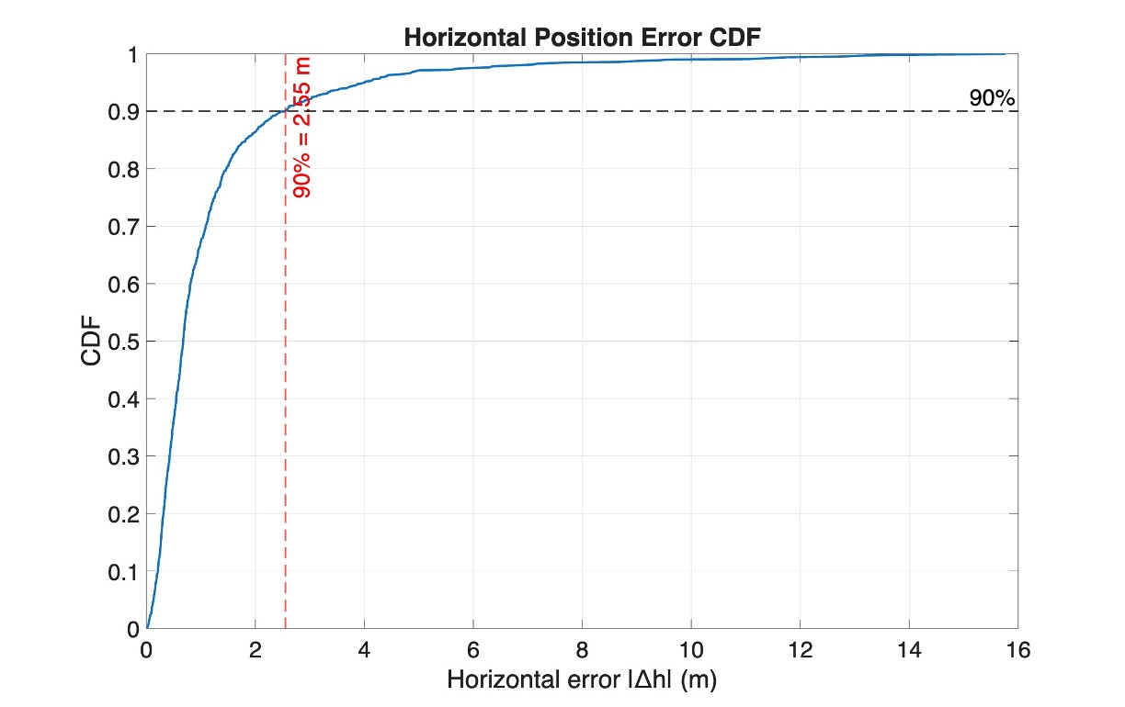 | 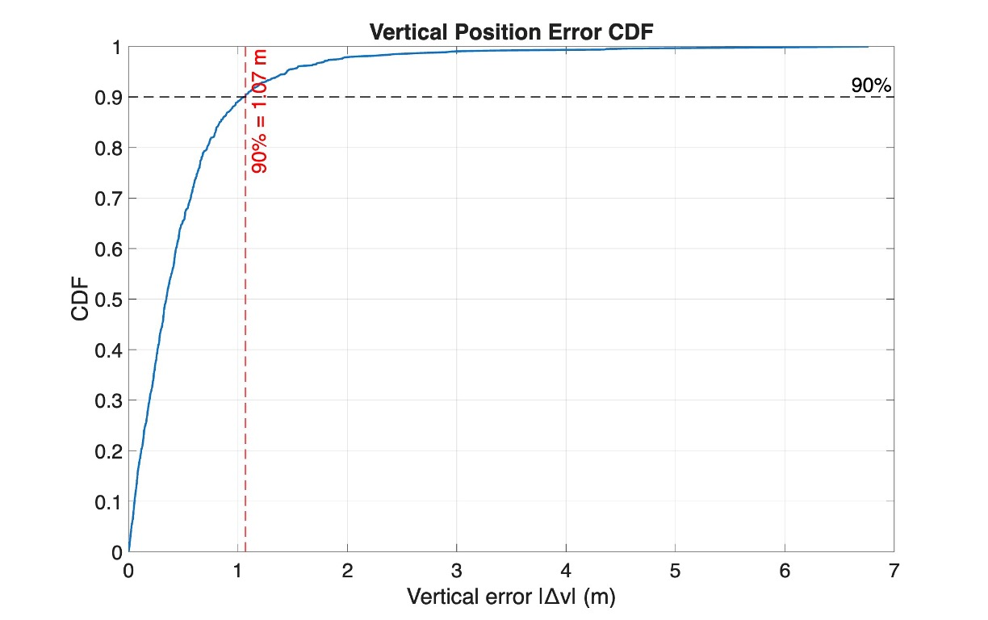 | 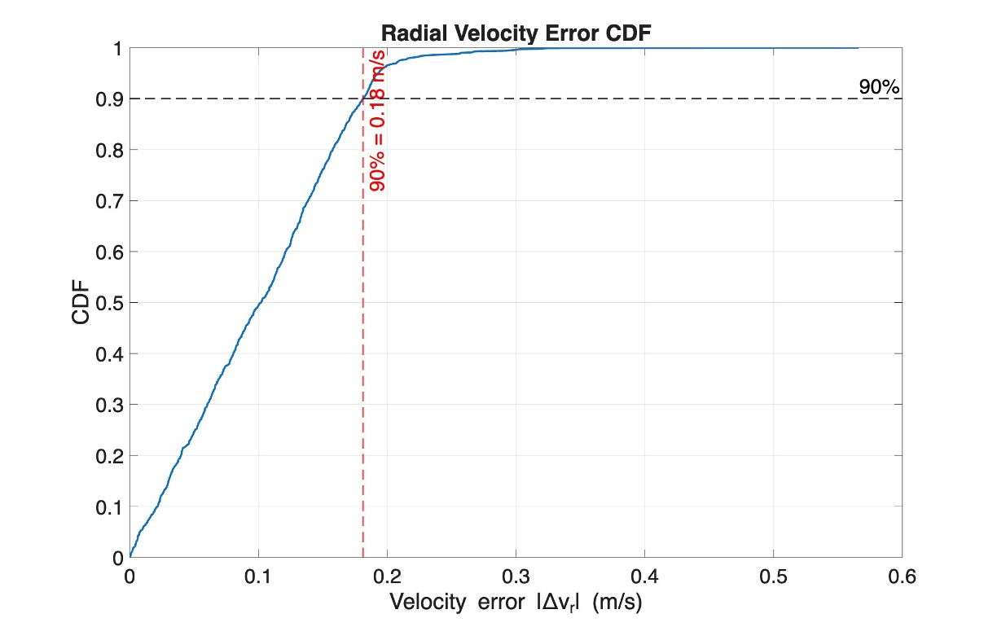
Figure 10: Horizontal, vertical, and velocity performance - Scenario 2

3.4.3 Sensing performance - Scenario 3
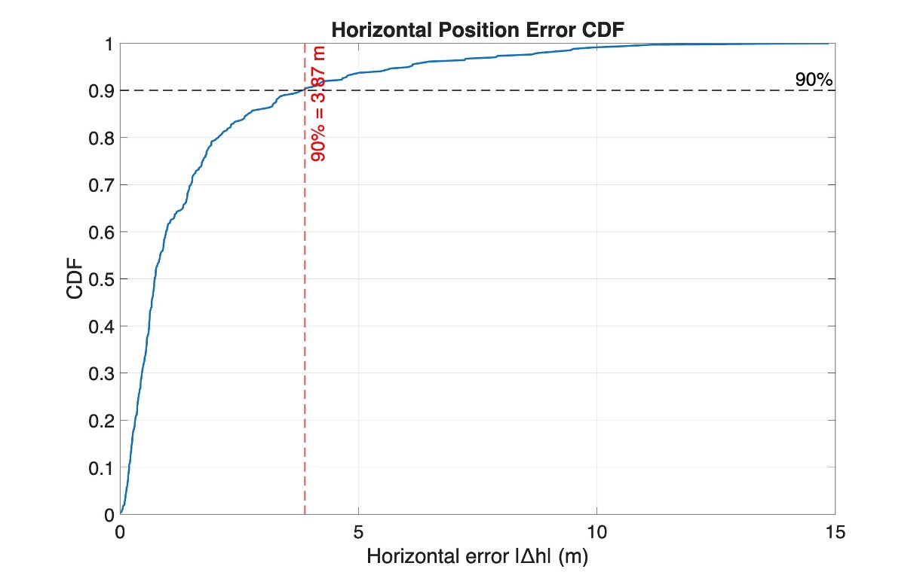 | 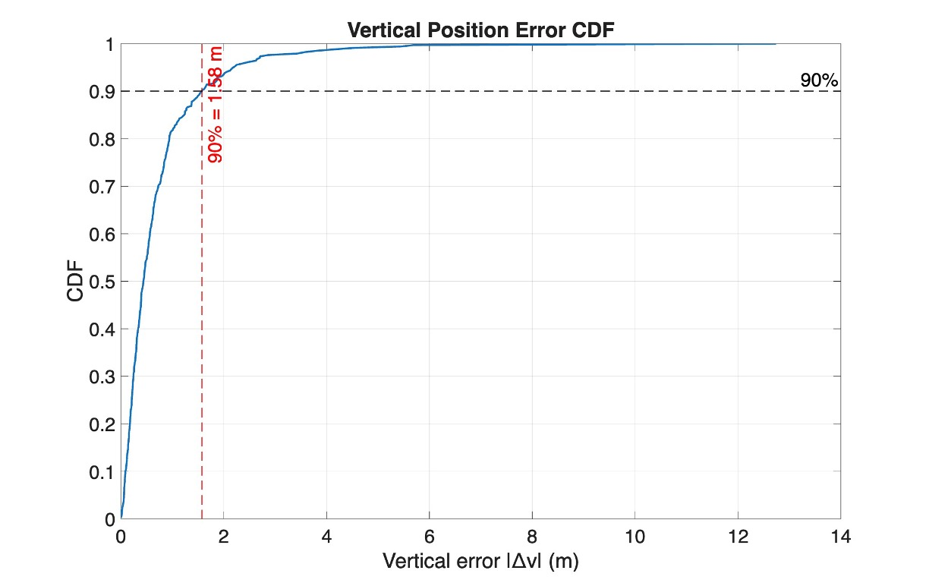 | 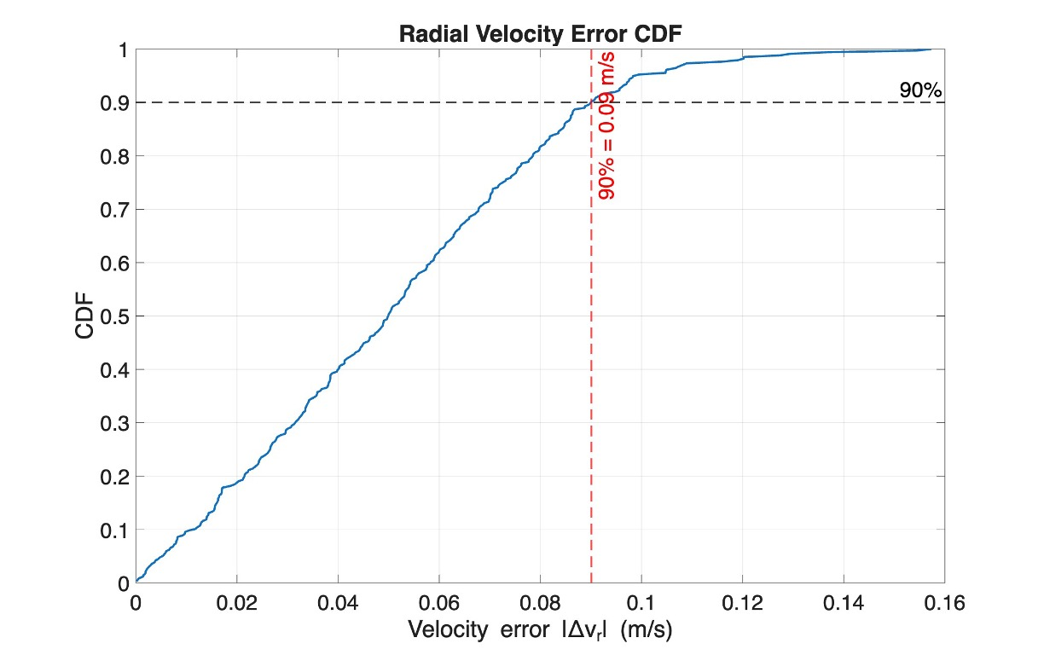
Figure 11: Horizontal, vertical, and velocity performance – Scenario 3

3.4.4 Summary of sensing performance
Table 3 provides a summary of the sensing performance results for the three scenarios we evaluated for both FDD (from previous contribution ‎[3]) and for TDD from the results in this contribution.
Table 3: Summary of the sensing performance of the three evaluated scenarios
Fram Structure | Scenario | Horizontal Pos. Error (90%) [m] | Vertical Pos. Error (90%) [m] | Velocity Error (90%) [m/s] | MDP  [%] | FA Type 1  [%] | FA Type 2  [%]
FDD | Scenario 1 | 2.74 | 1.21 | 0.36 | 4.2 | 0 | 2.18
FDD | Scenario 2 | 1.99 | 0.84 | 0.18 | 3.3 | 0 | 1.88
FDD | Scenario 3 | 3.47 | 1.64 | 0.09 | 3.8 | 0 | 3.07
TDD | Scenario 1 | 2.88 | 1.37 | 0.36 | 4.6 | 0 | 3.16
TDD | Scenario 2 | 2.57 | 1.07 | 0.18 | 3.6 | 0 | 1.68
TDD | Scenario 3 | 3.87 | 1.58 | 0.09 | 4.0 | 0 | 3.18

3.4.5 Communication channel performance
For the communications channel, the specific simulation parameters are as shown in Table 4.

Table 4: Communication channel specific parameters
Parameter | Value
Number of PRBs | 4
Chanel | TDL-C / TDL-D
UE speed | 120 km/h
SPDR | -25 dB / -32 dB

The performance of the communication system with and without the sensing signal for these simulation parameters was presented in ‎[4] and is also shown in the following figures.

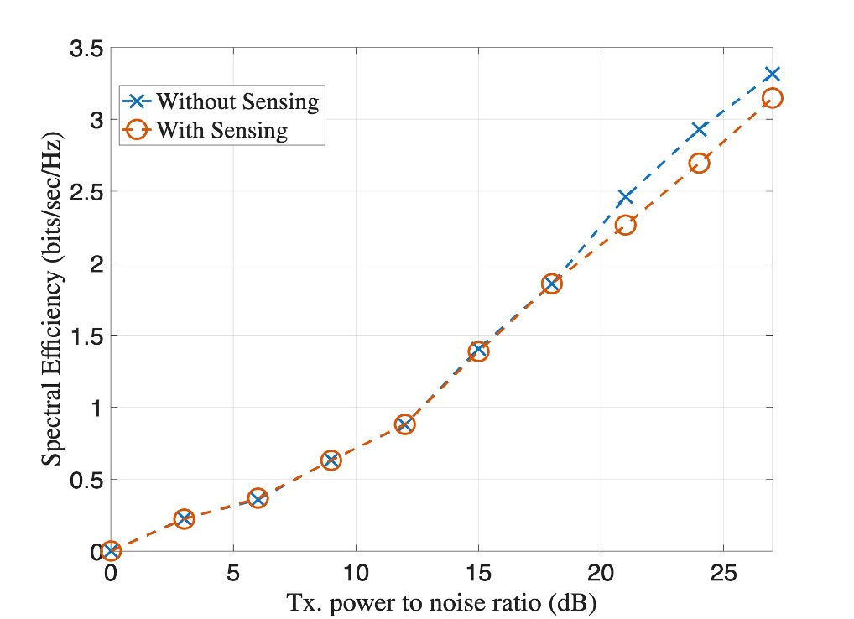
Figure 12: Spectral efficiency of the communication TDL-C channel with and without the sensing signal when SPDR = -25 dB

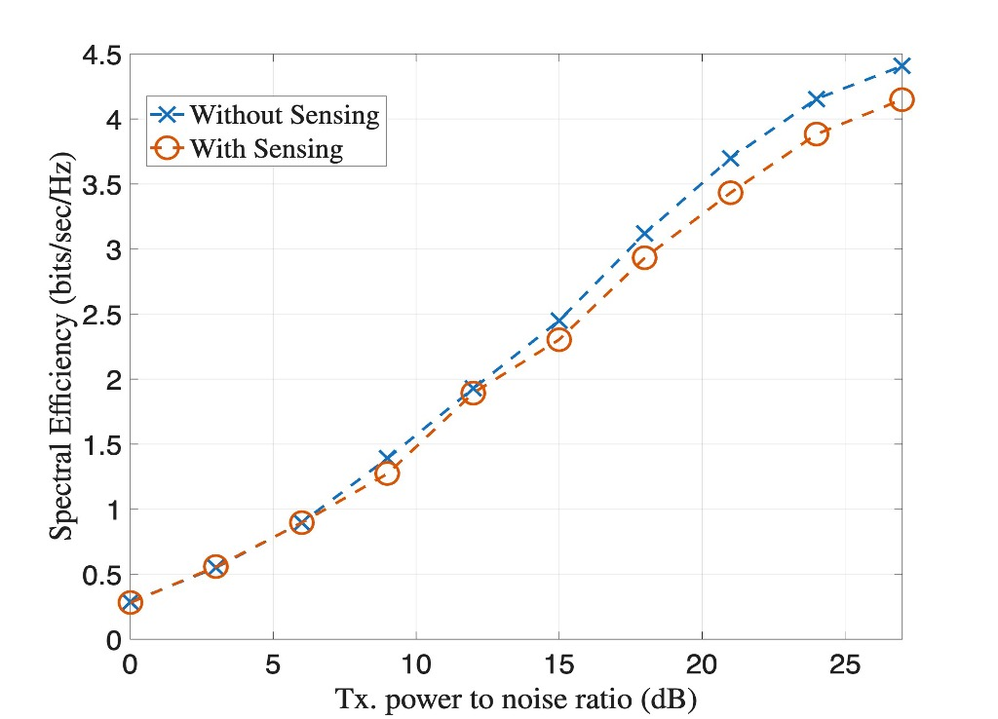
Figure 13: Spectral efficiency of the communication TDL-D channel with and without the sensing signal when SPDR = -25 dB

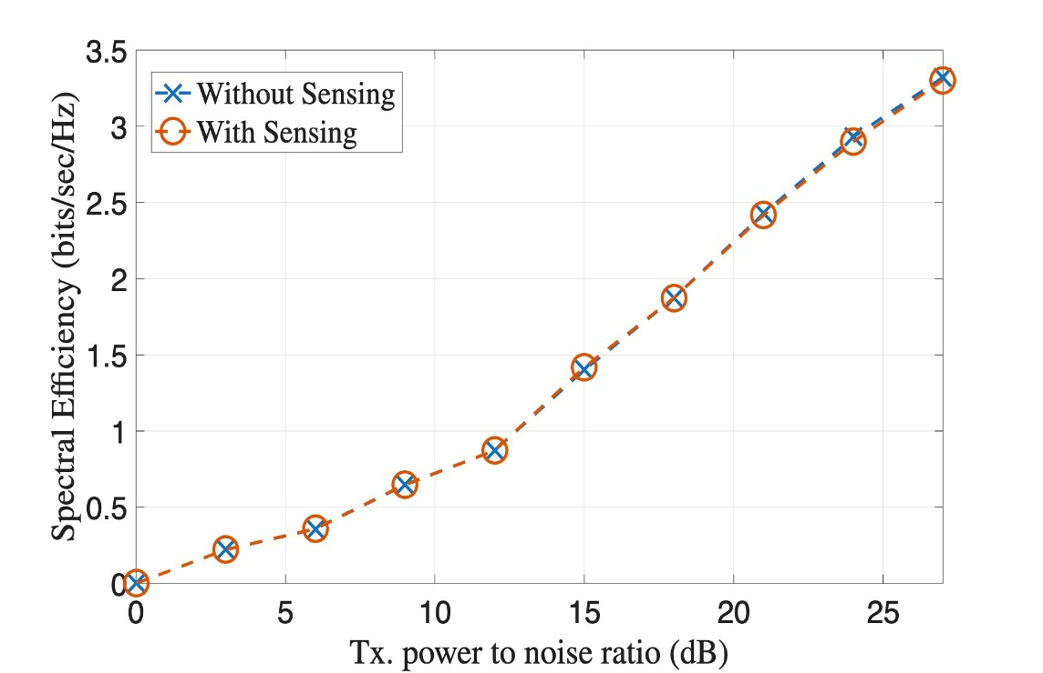
Figure 14: Spectral efficiency of the communication TDL-C channel with and without the sensing signal when SPDR = -32 dB

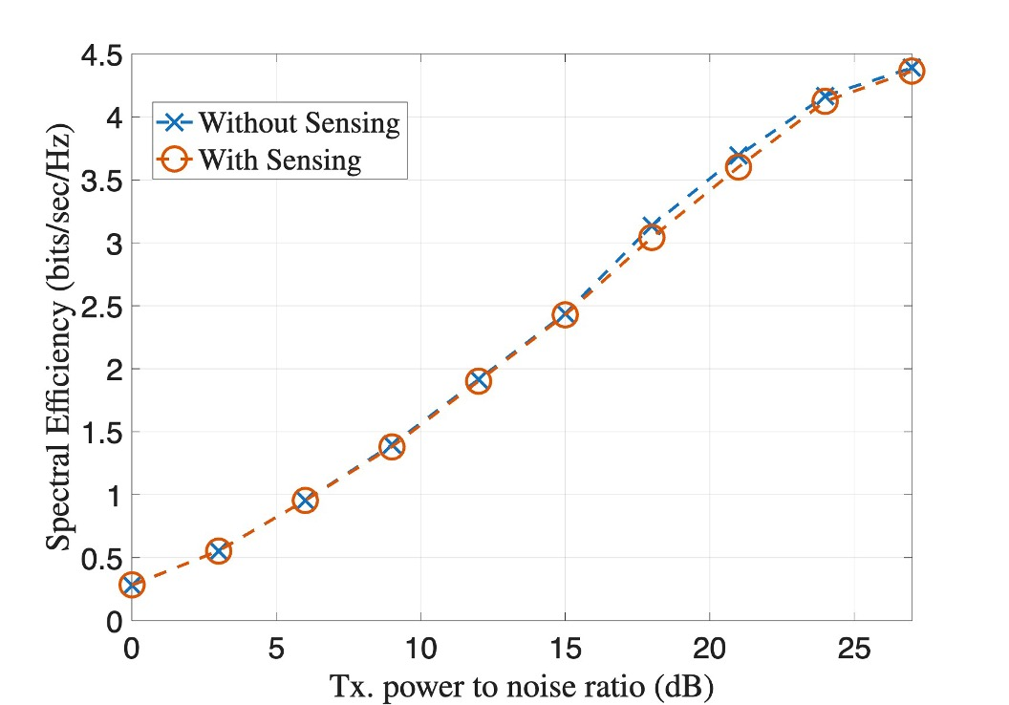
Figure 15: Spectral efficiency of the communication TDL-D channel with and without the sensing signal when SPDR = -32 dB

Observation 12: For 5G baseline configuration 1, the sensing signal based on overlaying of Zak-OTFS-over-OFDM pilot over the communications signal at SPDR of -25 dB or lower with 3-TRP cooperative sensing and 40 ms or higher CPI exceeds the 6G sensing performance requirements in both FDD and TDD configurations with close to zero overhead and negligible impact on the communication system performance.

Note that receivers that are aware of the sensing signal can choose to detect and subtract the sensing signal which could improve their spectral efficiency at very high SNRs. Alternatively, it is possible to lower SPDR to further reduce the interference to the communication signal, at the expense of higher CPI times. The receiver can also use the sensing signal to improve the channel estimation.

4 Discussion

4.1 Enhancements to CP-OFDM waveform for 6G ISAC
Based on what was presented in sections 2.1 and 3 we state the following:
Observation 13: The Zak-OTFS-over-CP-OFDM-based sensing signal presents at least the following benefits over using the 6GR CP-OFDM and proposed enhancements to the CP-OFDM for sensing:
- Zero overhead compared with measurable overheads of the other solutions
- Lower complexity
- Receiver flexibility in trading-off CPI for improved Doppler resolution and resilience to noise and interference
- Being agnostic to the communication waveform, i.e. the ability to be used with any communication waveform
- Supports all sensing modes and scenarios
- Flexible maximum range and Doppler spread support for different use cases and frequency bands
As a conclusion from the observation, we propose the following:
Proposal 1: Zak-OTFS-over-CP-OFDM based sensing will be part of the study of enhancements to be applied for CP-OFDM waveform for 6G ISAC

4.2 Specifying a monostatic and TRP-TRP bistatic waveform
The 5G sensing study showed that monostatic sensing can be accomplished without changing the air interface requirements. Our analysis also shows that good performance for sensing can be achieved without impacting the air interface requirements regardless of the waveform used communications (4G, 5G, 6G, WiFi, etc.). With that in mind, MNOs will not be tied to using a 3GPP defined solution for monostatic and TRP-TRP bistatic and may choose to use any solution that doesn't violate the 6G requirements. To summarize, our observation and proposals are the following:
Observation 14: There is no need for 3GPP to specify a waveform for TRP or UE monostatic or for TRP-TRP bistatic
Proposal 2: RAN1 will leave to implementation the following sensing modes: TRP monostatic, UE monostatic, TRP-TRP bistatic.

4.3 Evaluation methods
Our position is that to seriously evaluate proposed sensing solutions on aspects of performance (accuracy of detection, detection probability, false alarm), overhead, resiliency to noise and interference, coverage, etc., it is not enough to conduct theoretical waveform characteristics analysis. We contend that to evaluate all the parameters affecting the quality of the solution SLS should be run which include all cells and TRPs involved in both the sensing and interference. Hence, we propose the following:
Proposal 3: The evaluation of the different sensing proposals will include both SLS and theoretical waveform characteristics analysis

4.4 New waveforms for 6G ISAC
Observation 15: The pure Zak-OTFS based sensing signal presents at least the following benefits over using the 6GR CP-OFDM and proposed enhancements to the CP-OFDM for sensing:
- Zero overhead compared with measurable overheads of the other solutions
- Lower complexity
- Receiver flexibility in trading-off CPI for improved Doppler resolution and resilience to noise and interference
- Being agnostic to the communication waveform, i.e. the ability to be used with any communication waveform
- Supports all sensing modes and scenarios
- Flexible maximum range and Doppler spread support for different use cases and frequency bands
- Reduced PSLR through flexible pulse-shaping filter options
As a conclusion from the observation, we propose the following:
Proposal 4: pure Zak-OTFS based sensing will be part of the study of new waveforms for 6G ISAC

5 Conclusion
Observation 1: The sensing signal based on overlaying of Zak-OTFS-over-OFDM pilot over the communications signal is agnostic to the communication signal and can share the time-frequency resources with any communication waveform (4G, 5G, WiFi, etc.)

Observation 2: The sensing signal based on overlaying of Zak-OTFS-over-OFDM is considered as enhancement to 6GR CP-OFDM for communication

Observation 3: The sensing signal based on overlaying of Zak-OTFS-over-OFDM is applicable to all sensing modes

Observation 4: Using the Zak-OTFS-over-OFDM pilot as the sensing signal enables the use of a simple gating function to remove the sensing self-interference, simplifying the sensing receiver implementation.

Observation 5: The complexity associated with using the Zak-OTFS-over-OFDM based pilot is lower than using OFDM-based reference signals:
- The complexity of transferring the reflected signal to the delay-Doppler domain is NMlog(M)
- The self-interference removal using a gating function is lower complexity than self-interference removal using OFDM-based reference signals

Observation 6: The proposed Zak-OTFS-over-OFDM based ISAC, by sending the sensing pilot with no Doppler filter enables immediate sensing with no gaps in time and provides full flexibility to the sensing receiver to pick the CPI and by that the Doppler resolution and the sensing SINR appropriate for each sensing scenario.

Observation 7: The sensing signal based on overlaying of pure Zak-OTFS pilot over the communications signal is agnostic to the communication signal and can share the time-frequency resources with any communication waveform (4G, 5G, WiFi, etc.)

Observation 8: The sensing signal based on overlaying of pure Zak-OTFS is applicable to all sensing modes

Observation 9: Using the pure Zak-OTFS pilot as the sensing signal enables the use of a simple gating function to remove the sensing self-interference, simplifying the sensing receiver implementation.

Observation 10: The complexity associated with using the Zak-OTFS-over-OFDM based pilot is lower than using OFDM-based reference signals:
- The complexity of transferring the reflected signal to the delay-Doppler domain is Mlog(M)Nlog(N)
- The self-interference removal using a gating function is lower complexity than self-interference removal using OFDM-based reference signals

Observation 11: The proposed pure Zak-OTFS based ISAC, by sending the sensing pilot with no Doppler filter provides full flexibility to the sensing receiver to pick the CPI and by that the Doppler resolution and the sensing SINR appropriate for each sensing scenario.

Observation 12: For 5G baseline configuration 1, the sensing signal based on overlaying of Zak-OTFS-over-OFDM pilot over the communications signal at SPDR of -25 dB or lower with 3-TRP cooperative sensing and 40 ms or higher CPI exceeds the 6G sensing performance requirements in both FDD and TDD configurations with close to zero overhead and negligible impact on the communication system performance.

Observation 13: The Zak-OTFS-over-CP-OFDM-based sensing signal presents at least the following benefits over using the 6GR CP-OFDM and proposed enhancements to the CP=OFDM for sensing:
- Zero overhead compared with measurable overheads of the other solutions
- Lower complexity
- Receiver flexibility in trading-off CPI for improved Doppler resolution and resilience to noise and interference
- Being agnostic to the communication waveform, i.e. the ability to be used with any communication waveform
- Supports all sensing modes and scenarios
- Flexible maximum range and Doppler spread support for different use cases and frequency bands

Proposal 1: Zak-OTFS-over-OFDM based sensing will be part of the study of enhancements to be applied for CP-OFDM waveform for 6G ISAC

Observation 14: There is no need for 3GPP to specify a waveform for TRP or UE monostatic or for TRP-TRP bistatic
Proposal 2: RAN1 will leave to implementation the following sensing modes: TRP monostatic, UE monostatic, TRP-TRP bistatic.
Proposal 3: The evaluation of the different sensing proposals will include both SLS and theoretical waveform characteristics analysis
Observation 15: The pure Zak-OTFS based sensing signal presents at least the following benefits over using the 6GR CP-OFDM and proposed enhancements to the CP-OFDM for sensing:
- Zero overhead compared with measurable overheads of the other solutions
- Lower complexity
- Receiver flexibility in trading-off CPI for improved Doppler resolution and resilience to noise and interference
- Being agnostic to the communication waveform, i.e. the ability to be used with any communication waveform
- Supports all sensing modes and scenarios
- Flexible maximum range and Doppler spread support for different use cases and frequency bands
- Reduced PSLR through flexible pulse-shaping filter options
Proposal 4: Pure Zak-OTFS based sensing will be part of the study of new waveforms for 6G ISAC

References
- 3GPP TR 38.914 V0.4.0 (2026-03): "3rd Generation Partnership Project; Technical Specification Group Radio Access Network; Study on 6G Scenarios and Requirements; (Release 20)".
- S. K. Mohammed, R. Hadani, A. Chockalingam, and R. Calderbank, “OTFS – A mathematical foundation for communication and radar sensing in the delay-Doppler domain,” IEEE BITS the Information Theory Magazine, vol. 2, no. 2, pp. 36-55, 1 Nov. 2022.
- S. K. Mohammed, S. Prakash, M. Ubadah, I. A. Khan, R. Hadani, S. Rakib, S. Kons, Y. Hebron, A. Chockalingam, and R. Calderbank, "Zak-OTFS over CP-OFDM," arXiv:2508.03906v1 [eess.SP] 5 Aug 2025.
- R1-2602098, "On Waveform and Frame Structure for 6G ISAC," Cohere Technologies

